**GROUP 13**

|  |  |  |
| --- | --- | --- |
| **UFID** | **NAME** | **EMAIL** |
| 98831646 | MAYANK SHARMA | mayanksharma@ufl.edu |
| 80659919 | ISWARYA SUBBURAJ | iswarya.subburaj@ufl.edu |
| 01794985 | JAYETRI BARDHAN | jayetri.bardhan@ufl.edu |
| 85550520 | SIDDHARTH GUPTA | siddhartgupta@ufl.edu |

**INTERNATIONAL HEALTH AND POPULATION MATRICS APPLICATION**

**Table of Content:**

Overview and Introduction 2

lUser Interface Design 2

Conceptual Database Design ( ER Diagram) 4

# **Overview and Introduction:**

The project aim is to create a website for the international population database. Our application is designed for users who are interested in statistics and trends of world population based on various factors like age, sex, population by age, fertility rate, mortality rate, infant mortality and net migration. Some users of our application will be the Government of any country who wants to make policies to improve the standard of life for their country's people and a health services company to drill down their ideal customers and discovering profitable opportunities for marketing their products. For this project, the user will be able to retrieve information regarding the following functionalities: Population growth, Population density, Mortality,Age dependency, Life expectancy, Mobility Childbearing years.

This document contains User Interface Design and Conceptual Database Design. First, we have described the User Interface(UI) Design which will show the various web pages that are required to fulfill the requirement for our international population database application, the flow and action that is needed to move from one page to another. Second, we have described the Conceptual Database Design which will briefly explain our motivation for designing the Entity Relationship(ER) diagram and we will show our ER diagram to describe our data using entities, relationships, and attributes. So, from this document we can get an idea about what the front end and back end of our application looks like.

# **lUser Interface Design:**

This is the UI design representation of our project where all the webpages are depicted using nodes whereas the flow of logic from one webpage to other is represented by the edges of the graph. The following is an explanation of the UI design layout.

1. There are a total of 10 web pages containing all the required functionalities.
2. The first webpage is the login page where the user can enter details.
3. Once the user logins it directs to the home page (second page).
4. The user can navigate to all the other 8 pages from this login page (page 2). Also, the user will be able to navigate back to the home page from the eight pages.
5. The 8 main components that the functionalities will revolve around include: Population growth, Population density, Mortality,Age dependency, Life expectancy, Mobility Childbearing years and Review. Each of the functionalities are represented in each of the eight webpages.
6. The user can choose the webpage based on the functionality that the user is interested in.

# 

# **Conceptual Database Design ( ER Diagram):**

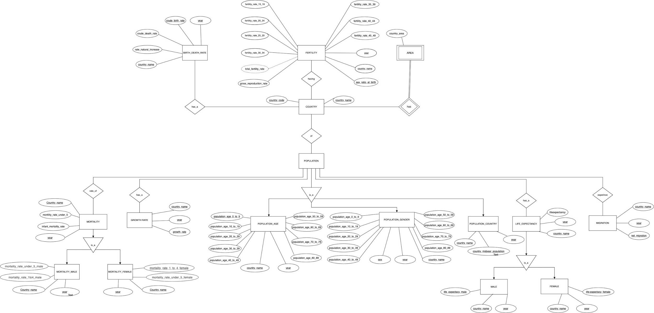

(Please zoom in to see the complete ER Diagram clearly)

**Motivation:**

Depending upon the functions and the data we collected, we have designed the ER diagram as follows:

The major functionalities of this project are Population growth, Population density, Mortality, Age dependency, Life expectancy, Mobility Childbearing years. So we have formed the entities: Birth_Death_rate, Fertility, Area, Country, Population, Mortality, Growth Rate, Population_Age, Population_Gender, Population_Country, Life_Expectancy, Migration, Mortality_Male, Mortality_Female,

Male, Female.

For the Birth_Death_rate entity, we provide the basic information: crude birth rate, country name, crude death rate, year, Net migration. In that country name, crude birth rate and year forms the primary key. The crude [birth rate](https://www.thoughtco.com/birth-rate-definition-3026096) is the rate of birth among a population of 1000 and crude death is the rate of deaths among a [population](https://www.thoughtco.com/what-is-demography-3026275) of 1,000. The net migration rate is the difference between the number of immigrants and the number of emigrants throughout the year. We have provided this entity because we think the information is needed for population growth functionality.

For the Fertility entity, we have the following attributes: country name, year, fertility_rate_15_19, fertility_rate_20_24, fertility_rate_25_29, fertility_rate_30_34, fertility_rate_35_39, fertility_rate_40_44, fertility_rate_45_49, total_fertility_rate, gross_reproduction_rate, sex_ratio_at_birth. For this entity, country name, year, sex_ratio_at_birth forms the primary key. We have made total_fertility_rate as a derived attribute because it can be calculated from the other attributes. The attribute fertility_rate_x_y means the age specific fertility rate between the age x and y, sec_ratio_at_birth is the ratio between male birth per female birth, gross reproduction rate is the lifetime births per woman. We needed this entity in order to get some information regarding the child bearing years functionality in our project.

The country entity has attributes like: country_code and country_name, which also forms the primary key. Country is used as an entity since all the functionalities used in this project have been categorized based on countries.

Area is a weak entity since it is dependent on the attributes of the strong entity- ‘country’. It has a country_area as an attribute.

The entity-mortality has the following attributes: country_name, mortality_rate_under_5, infant_mortality_rate and year. Among them, country_name and year forms the primary key. Mortality_rate_under_5 represents probability of children dying between the age of 0 to 5 while infant mortality can be defined as the infant deaths per 1000 population. We need this entity in order to calculate some functionalities like calculating the average mortality of the world.

Generalization (is_a type of relation) has been used to relate mortality_male and mortality_female with the mortality entity. The mortality_male entity has the following attributes: mortality_rate_under_5_male, mortality_rate_1to4_male, country_name and year. Country_name and year forms its primary key. Similarly, the mortality_female entity has the following attributes: mortality_rate_under_5_female, mortality_rate_1to4_female, country_name and year. Here also, country_name and year forms its primary key. Here, ‘mortality_rate_1to4_male’ refers to the probability of male children dying between 1 to 4 years.

Growth rate entity has three attributes- country_name, year and growth rate. All these three together form the primary key of ‘growth rate’. This entity is required in order to estimate some functionalities like doubling time and and zero population growth.

Generalization (is_a type of relation) again has been used to relate population_age, population_gender and population_country with population.

Population_age is a strong entity with attributes like: population_age_0_to_9, population_age_10_to_19,population_age_20_to_29,population_age_30_to_39, population_age_40_to_49, population_age_50_to_59, population_age_60_to_69, population_age_70_to_79, country_name and year. Here also, country_name and year forms the primary key. The attribute population_age_x_y represents the population of people within an age group of x and y. Population_age is used to derive few functionalities which will be later used in this project like- ‘age dependency ratio’.

Population_gender is again another strong entity having attributes such as: population_age_0_to_9, population_age_10_to_19,population_age_20_to_29,population_age_30_to_39, population_age_40_to_49, population_age_50_to_59, population_age_60_to_69, population_age_70_to_79, sex and year. Its primary key is sex and year. This entity describes the population of a specific gender.

Population_country has three attributes- country_name, year and country_midyear_population. These three together form the primary key of this entity. Mid-year population is the arithmetic mean of the population on 1 January and the population on 31 December of a year. It is used to calculate annual rates.

The strong entity- life expectancy is a statistical measure of the average time a person is expected to live, based on the year of its birth, its current age and other demographic factors including gender. Life expectancy, year and country_name are its attributes. The year and country_name here also form the primary key. It has two subclasses or entities- male and female which shares a generalization (is_a) relation with ‘life expectancy’. Male has three attributes- life_expectancy_male, country and year which also forms the primary key. Correspondingly, ‘female’ entity also has three attributes- life_expectancy_female, country and year. They also together represent the primary key for ‘female’ entity.

Migration is a strong entity with attributes like- country_name, year and migration. All the three attributes together form the primary key for migration. Net migration is the number of migrants per 1,000 population. Migration can be used to determine functionalities like rate of population growth and mobility, and hence has been chosen as an entity.

**Important Relationships:**

The ER diagram shows a lot of important relationships. Generalization (is_a type of relation) has been used in many instances in the diagram (Described above).

There also has been one occurrence of a derived attribute- total_fertility_rate which can be derived from the attributes like: fertility_rate_15_19, fertility_rate_20_24, fertility_rate_25_29, fertility_rate_30_34, fertility_rate_35_39, fertility_rate_40_44 and fertility_rate_45_49.